Reassessment of Impermeable Surfaces in The City of Winchester, VA: Final Report
October 10th, 2025

Prepared by:
Precision GIS
(Nathan Blechl, Chimaera Todd, Zaina Olibah)

Prepared for:
The City of Winchester, Virginia

Executive Summary

This project was conducted by the Precision GIS team in order to assess impervious surfaces in the City of Winchester, VA, to support accurate stormwater utility billing under the City’s new stormwater fee. The project uses 2023 and 2025 EagleView Technologies imagery to identify these changes in impervious areas such as roads, rooftops, driveways, parking lots, and turf athletic fields. The imagery received was mosaiced, segmented, and classified using ArcGIS Pro and PCI Geomatica. Strong accuracy was displayed in both of our team's previous and impervious classes. Our change analysis revealed especially large increases in residential and commercial areas such as apartment complexes and shopping centers, indicating population growth. The methodology, change analysis, and full deliverables are listed in this project. The information provided intends to sufficiently provide The City of Winchester with reliable data for their stormwater management fee.

Introduction and Background

This project intends to determine the area of impermeable surface on allotments of land in the City of Winchester, Virginia. The data of impervious surfaces in each parcel will be used to determine how much each landowner will be charged for the City’s stormwater management fee. The fee was introduced by the City of Winchester as a shared funding mechanism to maintain stormwater infrastructure, prevent flooding, mitigate costly natural disasters, and comply with state and federally mandated stormwater permits. Our project will identify and evaluate changes in impervious surface statistics using 2025 EagleView Technologies imagery against the previous baseline from 2023 EagleView Technologies imagery. Our team's main goal is to ensure accurate impervious surface data for the City of Winchester in order for the City to enact precise billing for its residents.

Data Sources Used

The following data was used for our team's project:

- 2025 EagleView Technologies high-resolution aerial imagery of the City of Winchester, Virginia, collected in March 2025. Provided by client

- 2023 EagleView Technologies high-resolution aerial imagery of the City of Winchester, Virginia, collected in 2023. Provided by client

- City of Winchester parcel boundary data. Provided by the employer

Methodology/Workflow

Mosaic

Firstly, using ArcGIS Pro, we used the Mosaic to New Raster tool to group the 2025 EagleView imagery files into 3 separate rasters, each with 21-22 tiles. This way, our entire team could work simultaneously and our computers could handle the large data.

Segmentation

After stitching the images together in ArcGIS Pro, we used PCI Geomatica to segment the 2025 EagleView Technologies image with the following default parameters: 25 scale, 0.5 rectangularity, and 0.5 compactness. These values were chosen in order to slightly oversegment the image, thus making the classification process more particular in order to achieve more accurate results.

Classification

When our segmentation was completed, we collected training data for our segmented imagery on PCI Geomatica in order to distinguish impervious from previous surfaces. For each class (impervious and pervious), we collected at least 20,000 segments across different types of terrain and land use in order to ensure accurate classification regardless of what was in the imagery. Totals of over 60,000 segments were collected for each class. After we collected the data, we used the Attribute Calculation function on PCI Geomatica in order to start our classification, calculating the following parameters: mean, maximum, minimum, standard deviation, perimeter, area, compactness, rectangularity, and NDVI). To account for computer error, we manually added more training data after our first classification and then re-ran it. Common errors that PCI Geomatica had trouble distinguishing between impervious and pervious were: trailers, water features (rivers, ponds), construction sites, brick structures, and concrete paths.

Merge + Dissolve

Following our classifications, we brought our data back into ArcGIS Pro to merge the 3 images together into one raster. Next, we used the dissolve tool to merge all adjacent impervious and previous features into 2 continuous classes.

Parcel Overlay

We used the City of Winchester parcel boundary data to clip our dissolved layer to the extent of the parcels. This way we can showcase and calculate just the impervious surfaces within the City limits.

Accuracy Assessment

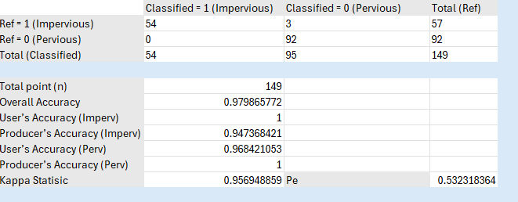
(Figure 1)

Our accuracy assessment compared the classified 2025 raster to manually verified reference points to evaluate the reliability of the impervious surface map. The results show strong performance (Figure 1), with a user’s accuracy for the impervious class and a producer’s accuracy for the pervious class both reaching 100%. These values indicate that when the model labeled a pixel as impervious, it was always correct within our sample, and nearly all true pervious areas were properly identified.

However, we recognize that this 100% accuracy is likely an artifact of our limited sample size rather than a perfect classification. If the number of reference points were increased, additional minor errors would likely appear, especially in areas with subtle surface differences. Most existing errors were impervious features misclassified as pervious, such as dark roofs, driveways, or paved paths that visually blended with surrounding vegetation. The few errors in the opposite direction involved shadows or thin linear features in fields that were misinterpreted as impervious. These were easy to identify during the manual classification phase, suggesting that our final map provides a reliable yet realistically imperfect representation of impervious and pervious surfaces across Winchester.

Results and Analysis
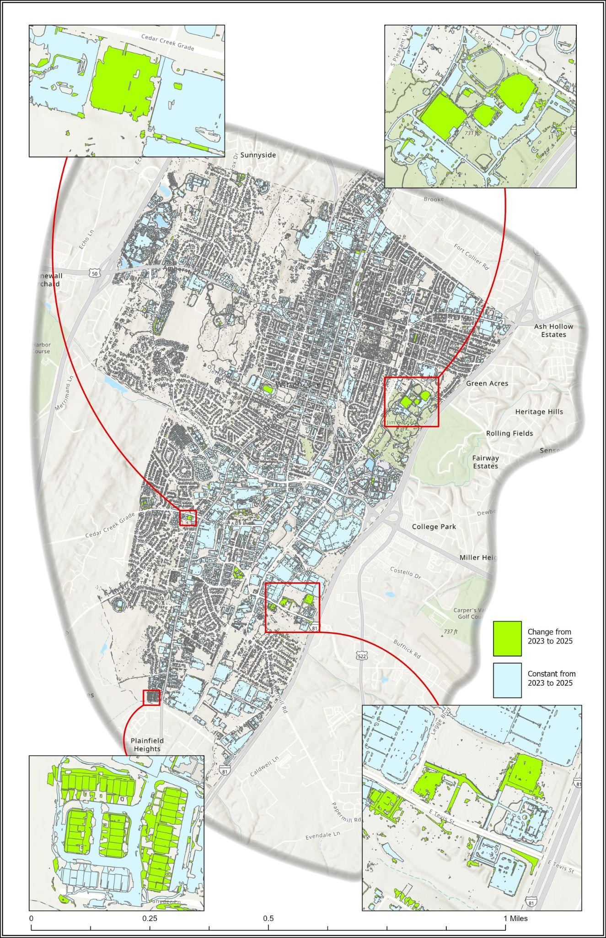
(Figure 2)

Above (Figure 2) is our change analysis map, displaying the changes in impervious surfaces from 2023 to 2025. The green polygons represent changes in impervious surfaces from 2023 to 2025, while the light blue polygons represent constants in impervious surfaces from 2023 to 2025.

Purpose

The change analysis is needed so we can identify how impervious surfaces have changed over the 2 year span in the City. This is important because it allows the City to update stormwater billing fairly and accurately while understanding trends in growth in urban areas with runoff potential.

Method

The erase tool was used in ArcGIS Pro with both the 2023 impervious parcel layer and the 2025 impervious parcel layer. The outcome layer of the erase tool was named “Change from 2023 to 2025” then overlaid on top of the 2025 impervious parcel layer, it was highlighted in a green color to stick out over the other dataset. The 2025 impervious layer was named "Constant from 2023 to 2025” and colored a light blue.

Spatial Patterns

The changes in impervious surfaces from 2023 to 2025 were most strongly seen in residential areas. In Figure 2, the bottom left inset map displays an apartment complex named Lofts at Creekside on Eton Pl. that shows a severe increase in impervious surfaces through new residential construction. The bottom right image in Figure 2 displays the Shoppes at Crossover shopping center, a new shopping center for local Winchester residents. The top left image in Figure 2 is Winchester Smiles of Virginia Family Dental Center, a newly built dentist office. The top right image in Figure 2 is newly constructed turf baseball fields.

Interpretation

An increase in impervious surface in the form of mostly residential and consumeristic buildings indicates a growth in population in The City of Winchester. Having more residents produces a population-driven demand for goods, services, and shopping. This can be seen through the growth in the apartment complex on Eton Pl. (Figure 2, bottom left), and the Shoppes at Crossover shopping center (Figure 2, bottom right). In regards to The City of Winchester's stormwater fee, this increase in impervious surfaces and population implies an elevated local runoff volume but also an increase in funds via their $0.22 per parcel fee.
Billing Calculations

The impervious surface fee for each parcel in the City was calculated using The City of Winchester's proposed storm water utility fee at a price of $0.22 per 50 sq. ft. of impervious area. Listed below in Deliverables Summary is the billing data and calculations, including:

- SUM_Imp_SqFt - the total impervious area per parcel, created by summing all Imp_SqFt values that share the same Parcel ID (PID). It gives the overall impervious square footage for each property.
- Billunits - the billing units of an individual parcel
- Fee - the monetary cost an individual parcel owes in USD
- FULLADDR - the physical address of an individual parcel

The total monetary amount was also calculated by adding all of the individual parcel fees, the amount is: $442,142.14*

*this amount does not include railroads in The City of Winchester, as they were not included in the parcel boundaries
Deliverables Summary

Project deliverables (link removed from this web copy)

Final_Deliverables_GrandChallenge1.gdb:
- Accuracy_Assessment_points_2025: This point layer contains the points with their manual classifications (Ref_Class) and their classifications extracted from our Classification_Raster_2025 (RASTERVALU)
- Change_analysis_2023to2025
- Impervious_2025_Polygons: polygon dataset of impervious features by parcel. Imp_SqFt represents the area of each individual impervious polygon (in square feet) within a parcel
- Parcel_Fee_2025_Final: Billing calculations per parcel (see Billing Calculations section for terminology)
- Classification_Raster_2025: The raster of the classified Pervious and Impervious features (OutClassFl) that was made from our 3 raster classification from PCI Geomatica

Change_analysis_layout.tif
- The map (Figure 2) displaying our change analysis

Confusion Matrix.xlsx
- The confusion matrix from our accuracy assessment

Parcel_Fee_2025_Final.xlsx
- The impervious surface fee for each parcel in The City of Winchester (see Billing Calculations)

Precision GIS Contact Information

Please refer to the following email and/or phone number with any questions/inquires:

Email: PrecisionGIS@dukes.jmu.edu
Phone: [removed from this web copy]

