Geography 470 Final Project

Chimaera Todd

Lessons from the TVA: Creating Federal Programs in Appalachia

Appalachia, as defined by the Appalachian Regional Commission (ARC), is a conglomeration of 423 counties across 13 states. The Appalachian region is defined by its mountainous terrain, cultural heritage, and numerous socioeconomic ills. Over the past century, there have been various efforts to address these teething issues, which include poverty, poor education, insufficient healthcare access, and various other dilemmas. One of the most successful programs that helped advance Appalachia was the New Deal of the 1930s, which created various federal programs to employ out of work Americans and build public works projects during the Great Depression era. Standing out from the lineup of New Deal initiatives is the Tennessee Valley Authority, which continues to operate today.

History and Impacts of the TVA

The Tennessee Valley Authority (TVA) was created in 1933 to address flooding that commonly occurred in the Tennessee River valley. It achieved this through the construction of dams, which were equipped with hydroelectric generators. These generators were able to produce clean and cheap electricity for the Tennessee River valley and the surrounding southern Appalachian region. Prior to 1959, the TVA was fully federally funded and enjoyed high levels of operational freedom that made it highly competitive (Marti) and developed programs for recreation and economic development. After being forced to be self-funding, the TVA continued to grow, constructing coal and nuclear power plants. Today, it exists primarily as a public power utility and has an operating capacity of 35 gigawatts from 7 nuclear reactors, 4 coal powerplants, 18 gas powerplants, 29 dams, 1 pumped storage hydroelectric complex, 1 wind turbine complex, and 14 solar farms, all of which is transmitted through over 16,000 miles of power lines (TVA). This makes it the sixth largest power supplier in the country.

The TVA was arguably the largest singlehanded driver of socioeconomic development in southern Appalachia in history. It brought the region out of abject poverty and brought electricity at affordable rates to some of the poorest Americans. It created jobs where there were very few before and provided value to the regional economy. However, many of the other socioeconomic issues that Appalachians struggled with continue to thrive today. Southern Appalachia remains one of the poorest parts of the country. This begs the question - can new New Deal-style federal programs be successful at addressing other systemic problems in Appalachia?

This project explores four theoretical bills sent to congress that each create a federal program addressing one issue in Appalachia - healthcare, higher education, public transportation, and tourism. Each bill will use data to show where revenue is needed, how it can best be utilized, and what effect it might have on the socioeconomic landscape of the region.

Appalachian Healthcare Commission (AHC) Act

An act to improve access to healthcare in Appalachia, to provide more affordable healthcare options in Appalachia, to create a greater number of healthcare jobs and provide more healthcare training in Appalachia, and to improve the health of Appalachians in general.

Appalachia as a region has some of the statistically worst healthcare in the United States. 10 of the 13 Appalachian states fall in the bottom half of all US states for general healthiness (United Health Foundation), while the average life expectancy is often below 70 in Appalachian counties (Institute for Health Metrics and Evaluation). Many locations are far from hospitals or clinics which severely limits access to healthcare services.

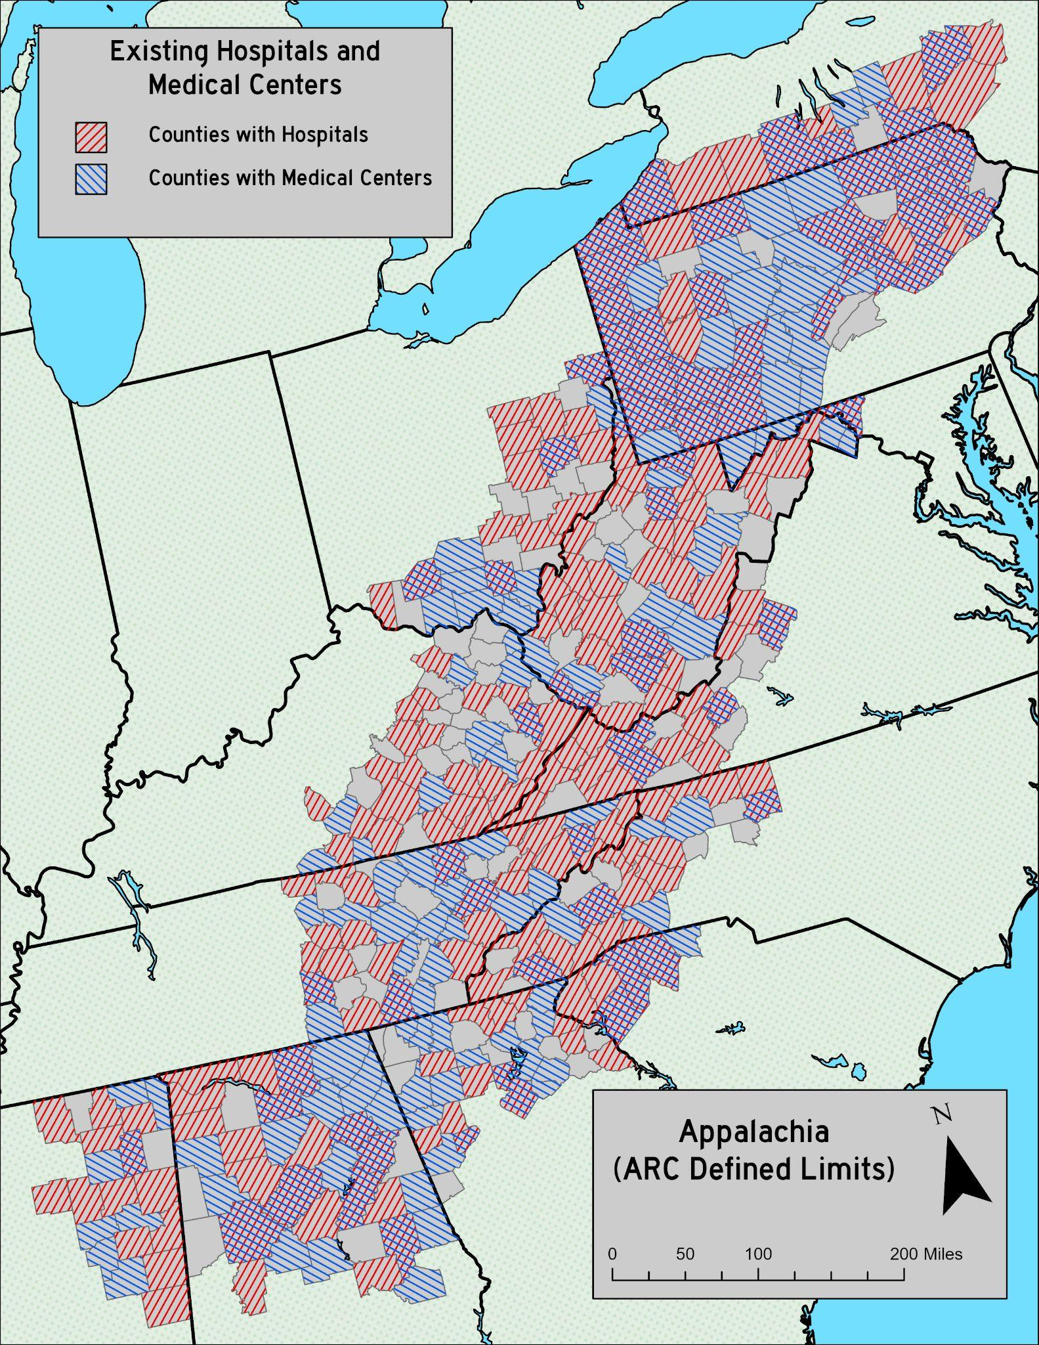
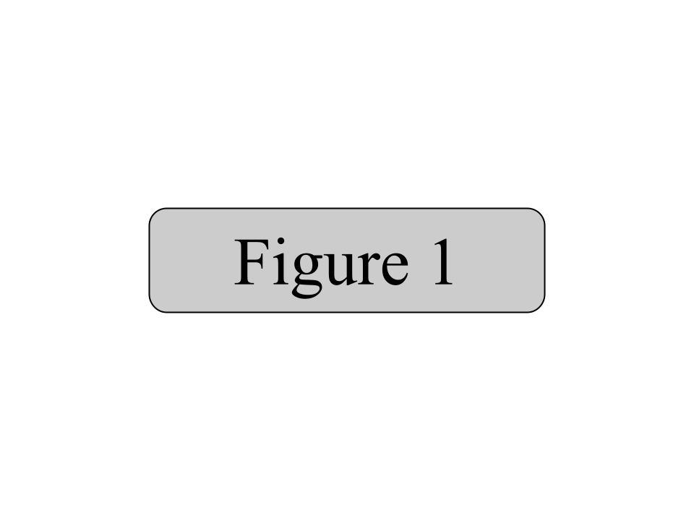
This act aims to increase the number of clinics in Appalachia in order to improve the distribution of healthcare access throughout the region. New clinics will be federally funded and offer affordable care through the Affordable Care Act supplemented by AHC care providing funds. In order to determine where new healthcare facilities are needed most, the spatial distribution of existing healthcare facilities was analyzed.

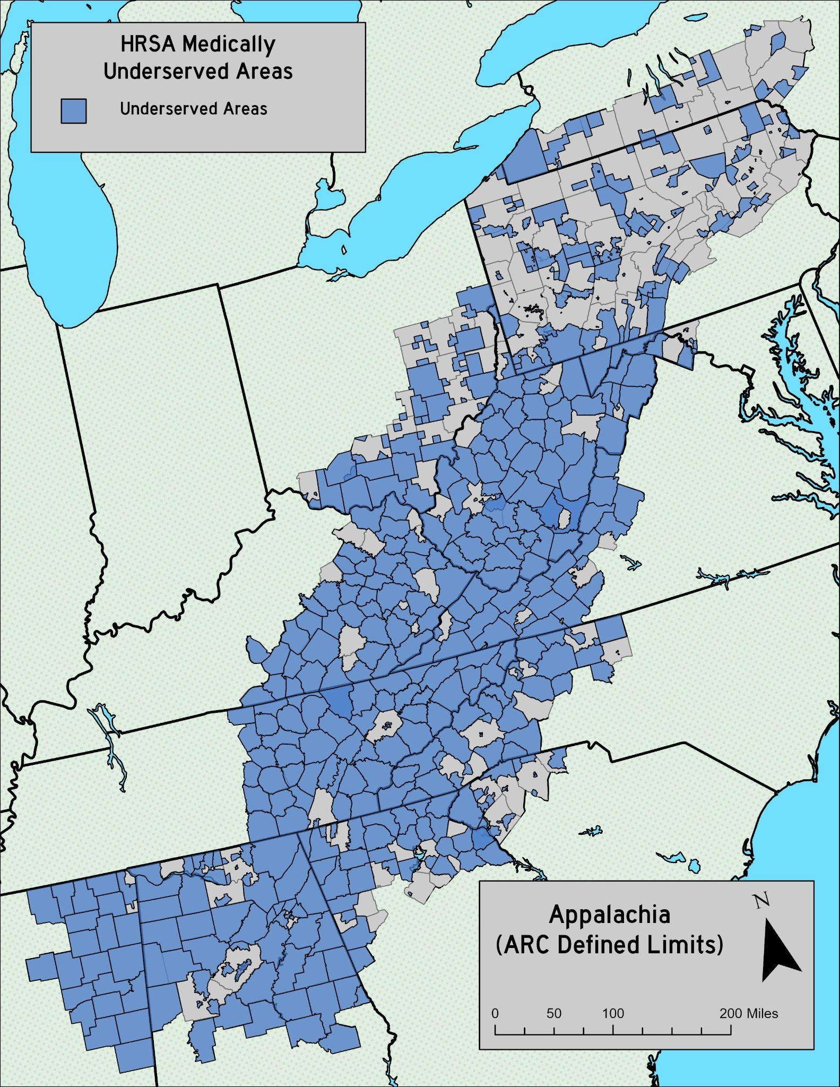
Healthcare location data was acquired from OpenStreetMap and visualized in ArcGIS Pro. Healthcare coverage was aggregated by county, and visualized for analysis. Figure 1 shows the aggregated distribution of existing healthcare coverage within ARC-defined Appalachian counties.

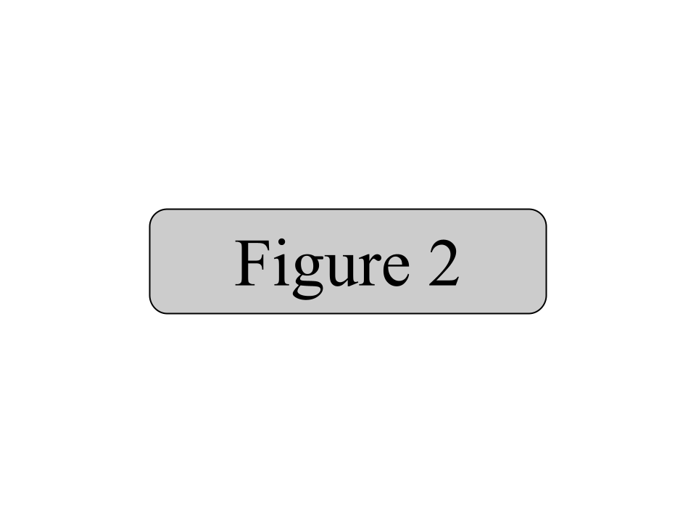
According to the data, there is a lack of hospitals in central Pennsylvania, southern Ohio, northeastern Alabama, and central eastern Tennessee. There is a lack of non-hospital medical centers in western West Virginia, far western Virginia, east central Kentucky, and east central Ohio. These areas reflect healthcare deserts as demarcated by the Health Resources and Services Administration. These deserts are visualized in figure 2.

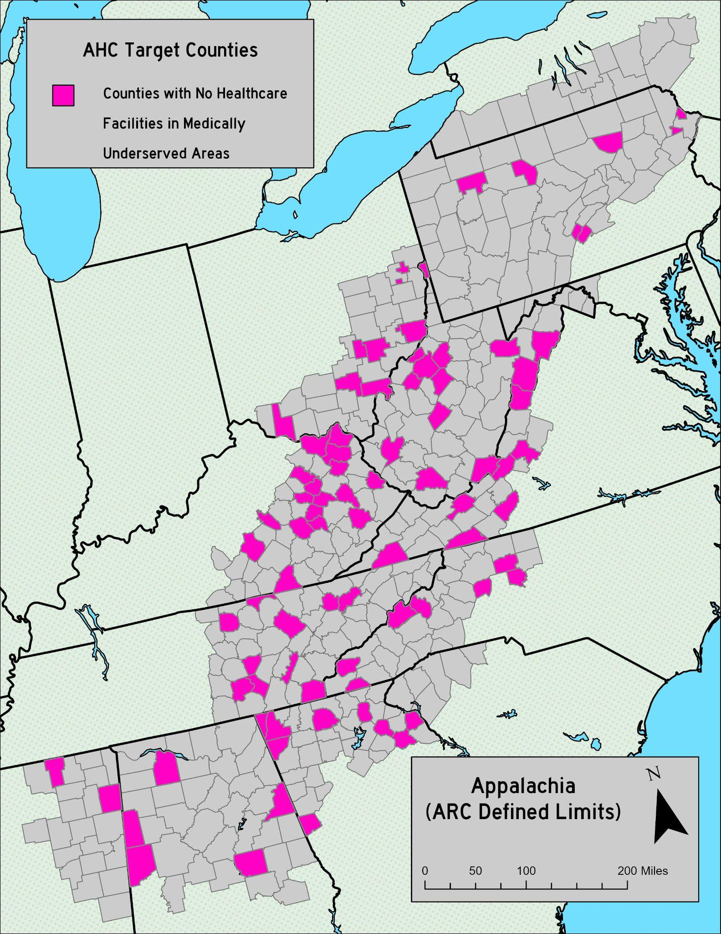
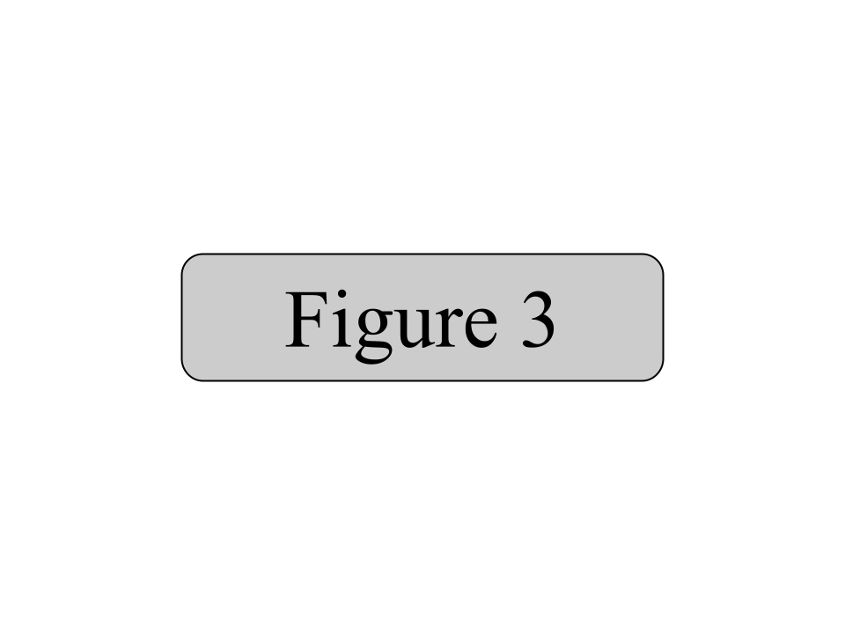
This shows that there are huge medically underserved areas (MUAs) throughout Appalachia, especially in the central and southern parts of the region. In order to address this, the AHC will construct new hospitals and medical centers. The locations will be based on both the locations of current healthcare facilities and MUA designations.

The AHC will target counties that are both lacking healthcare centers and are considered medically underserved. Figure 3 shows the distribution of counties that meet these requirements. Many of these countries are located in central Appalachia. Few counties in northern Appalachia (including seven in Pennsylvania and none in New York) meet these requirements.

These target counties will receive healthcare centers under AHC direction. These centers will be fully funded by the AHC and provide care using the strategy previously mentioned. As the AHC grows, it will expand its scope of influence to other MUAs that already have healthcare facilities. It will work in partnership with these existing facilities to provide care to underserved residents in the surrounding areas.

Overall, the AHC will expand healthcare services and work to achieve its foundational goal of manifesting a healthier Appalachia. Through building new healthcare facilities and working alongside existing providers, the AHC will be helping the Appalachian region take steps to move beyond its current health crisis.

Appalachian University and Trade Education Coalition (AUTEC) Act

An act to expand the accessibility of higher education in Appalachia, to provide affordable and flexible higher education offerings in Appalachia, to increase the scope of trade education in said region, and to promote workforce preparedness across all of Appalachia.
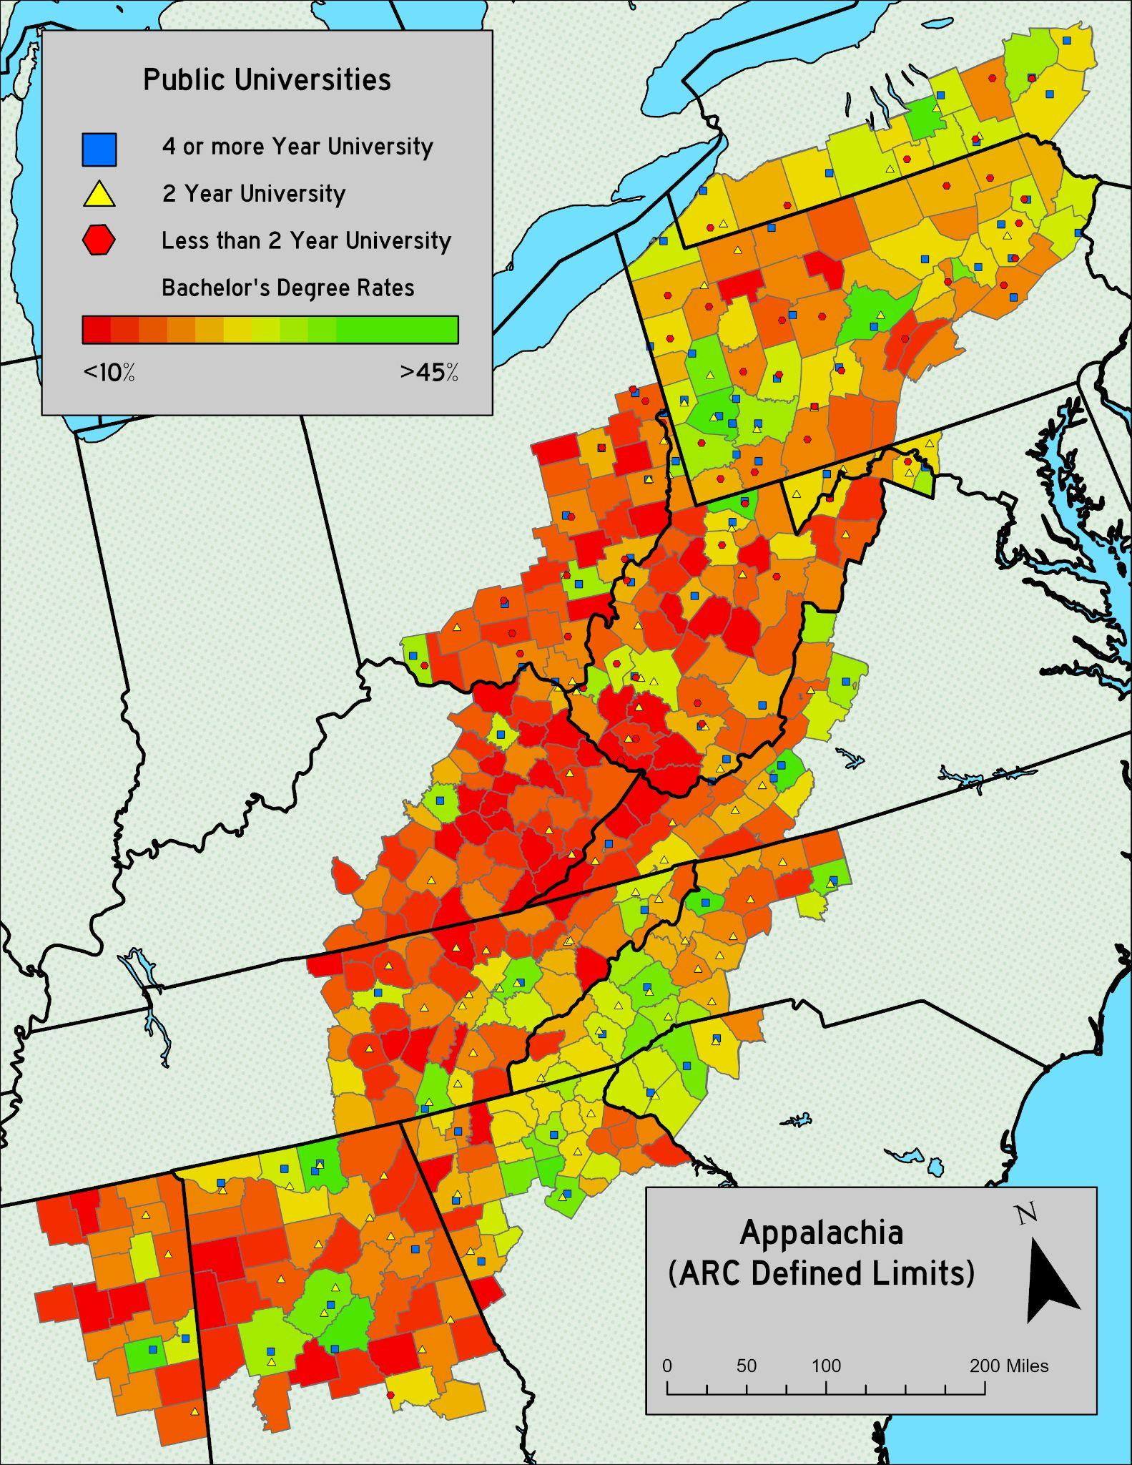
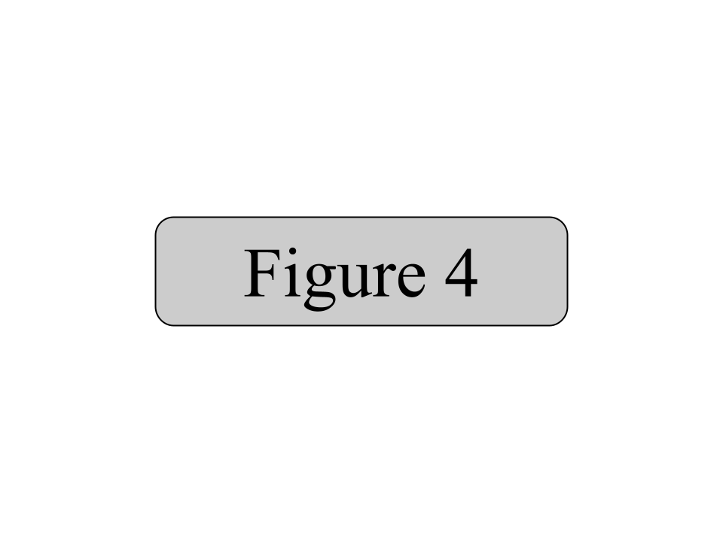
Appalachia is one of the generally least educated parts of the country, with 4-or-more-year university graduation rates in most counties between 10% and 20% compared to the national average of 35% to 40% (US Census Bureau). This lack of education limits the growth of the professional workforce and hinders individual’s abilities to get high paying, steady, white collar jobs needed for a functional middle class.

Figure 4 shows the distribution of public universities (4 or more year, 2 year, less than 2 year) overlaid on the rates of bachelor’s degree rates in Appalachia. As expected, the counties with the highest rates of bachelor’s degrees are in close proximity to 4 or more year universities. These areas are highly clustered in Pennsylvania and New York, western North Carolina, north Georgia, and central and northern Alabama.

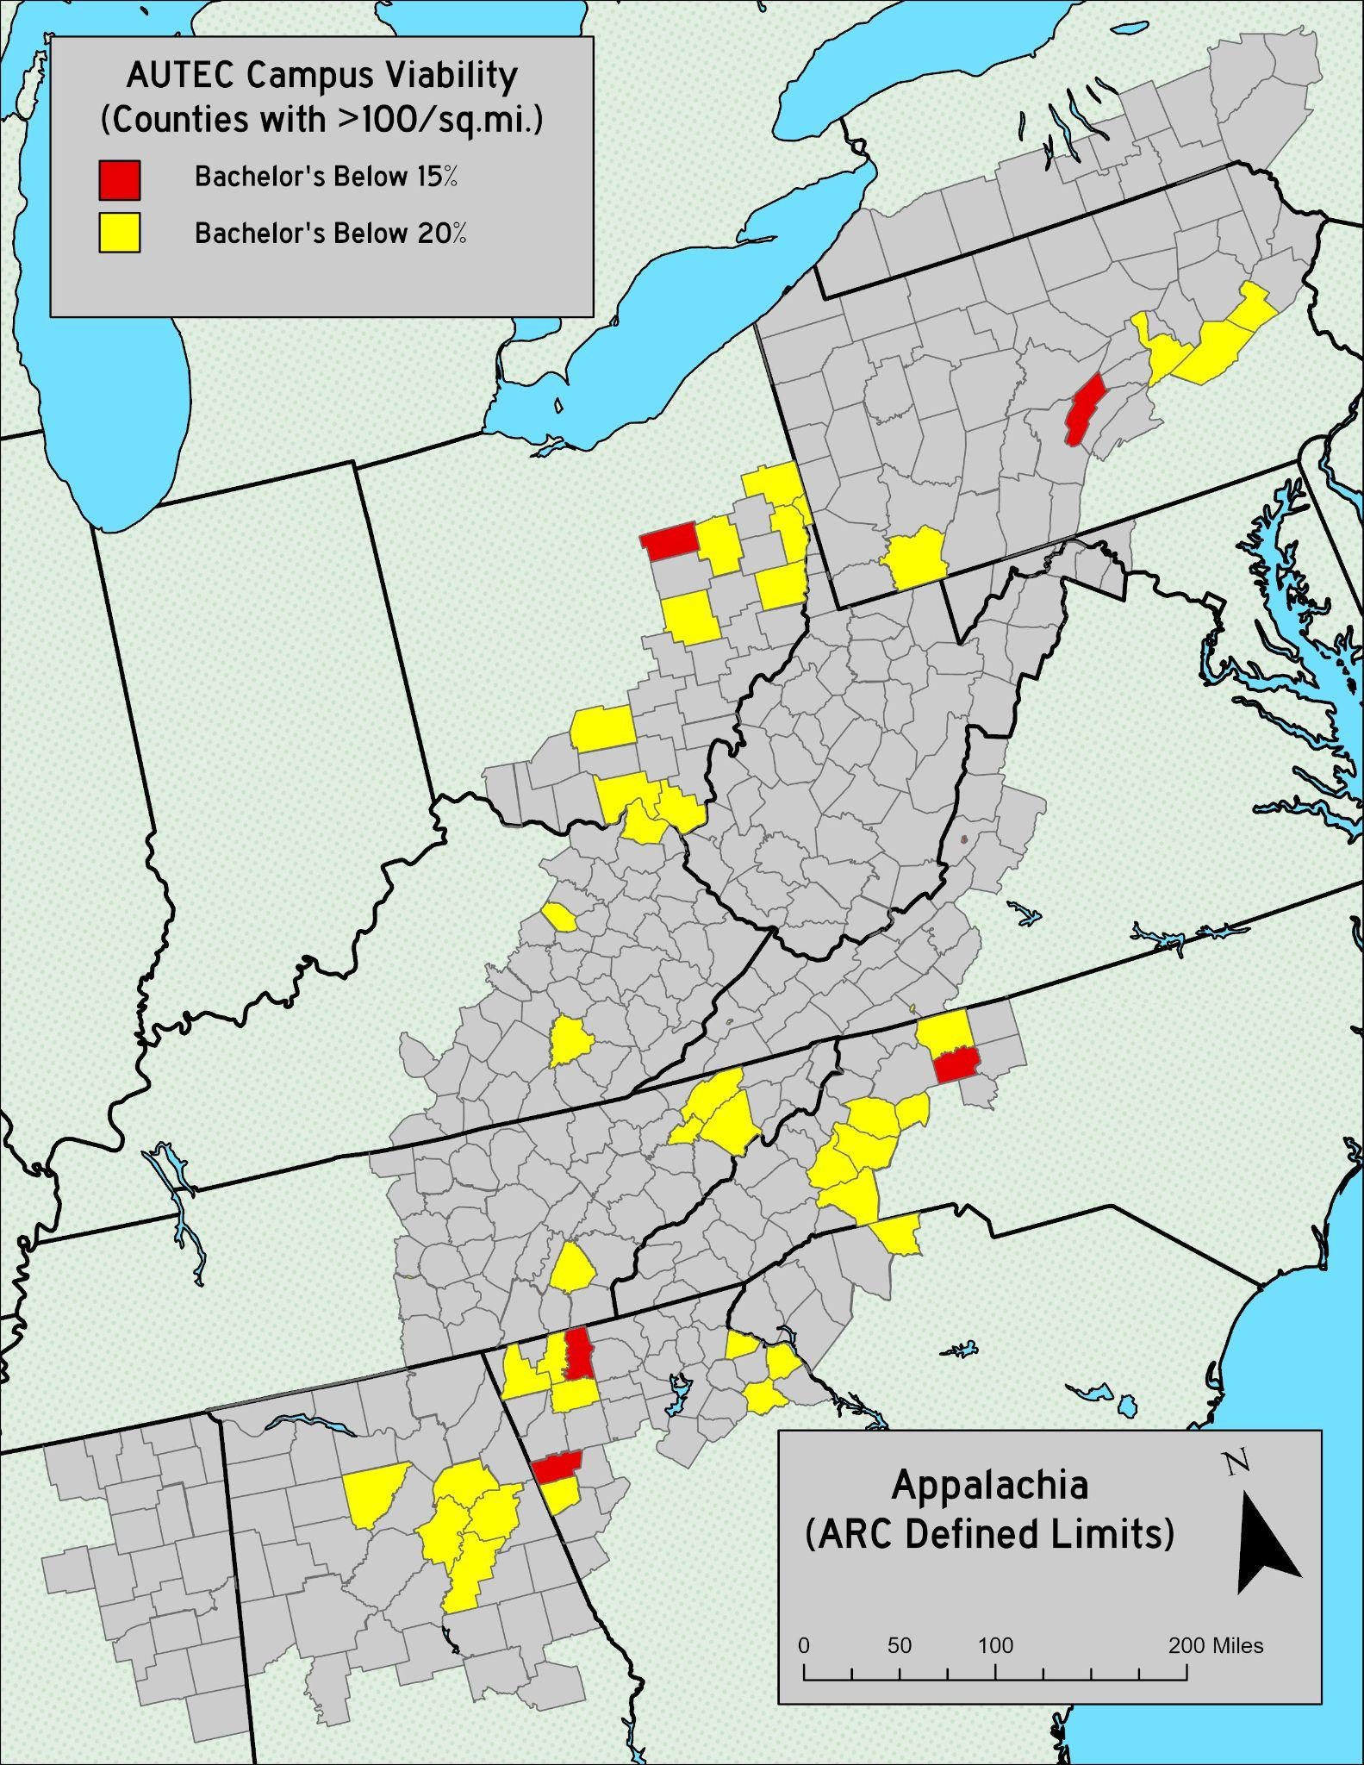
The areas with the least higher education rates are in university-light areas. Eastern Tennessee and Kentucky, western Virginia, southeastern Ohio, central and southwestern West Virginia, and northeastern Mississippi have very low rates of bachelor’s degree attainment. These areas have some of the lowest higher education rates in the country. AUTEC aims to rectify this disparity.

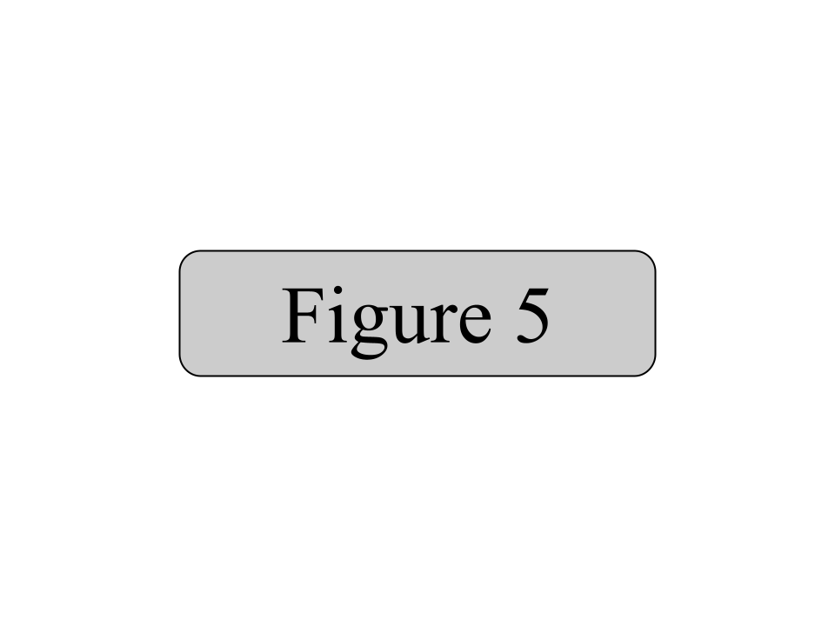
AUTEC will achieve this by acting as a federally funded coalition between 4-year public universities in Appalachia. Using federal funds, AUTEC will construct satellite campuses in the most educationally lacking regions. These campuses will be operated by the public universities within the AUTEC system. AUTEC funding will be used to create and distribute grants to qualifying prospective students within the Appalachian region, both to those attending AUTEC built satellite campuses and to those attending AUTEC member main campuses.

To determine where satellite campuses would best be suited, a site suitability map was created. Examining only counties with more than 100 residents per square mile, as counties with a less dense population than that would be impractical to build campuses on, counties with fewer than 20% bachelor’s degree attainment were selected as candidates. This suitability is visualized in figure 5.

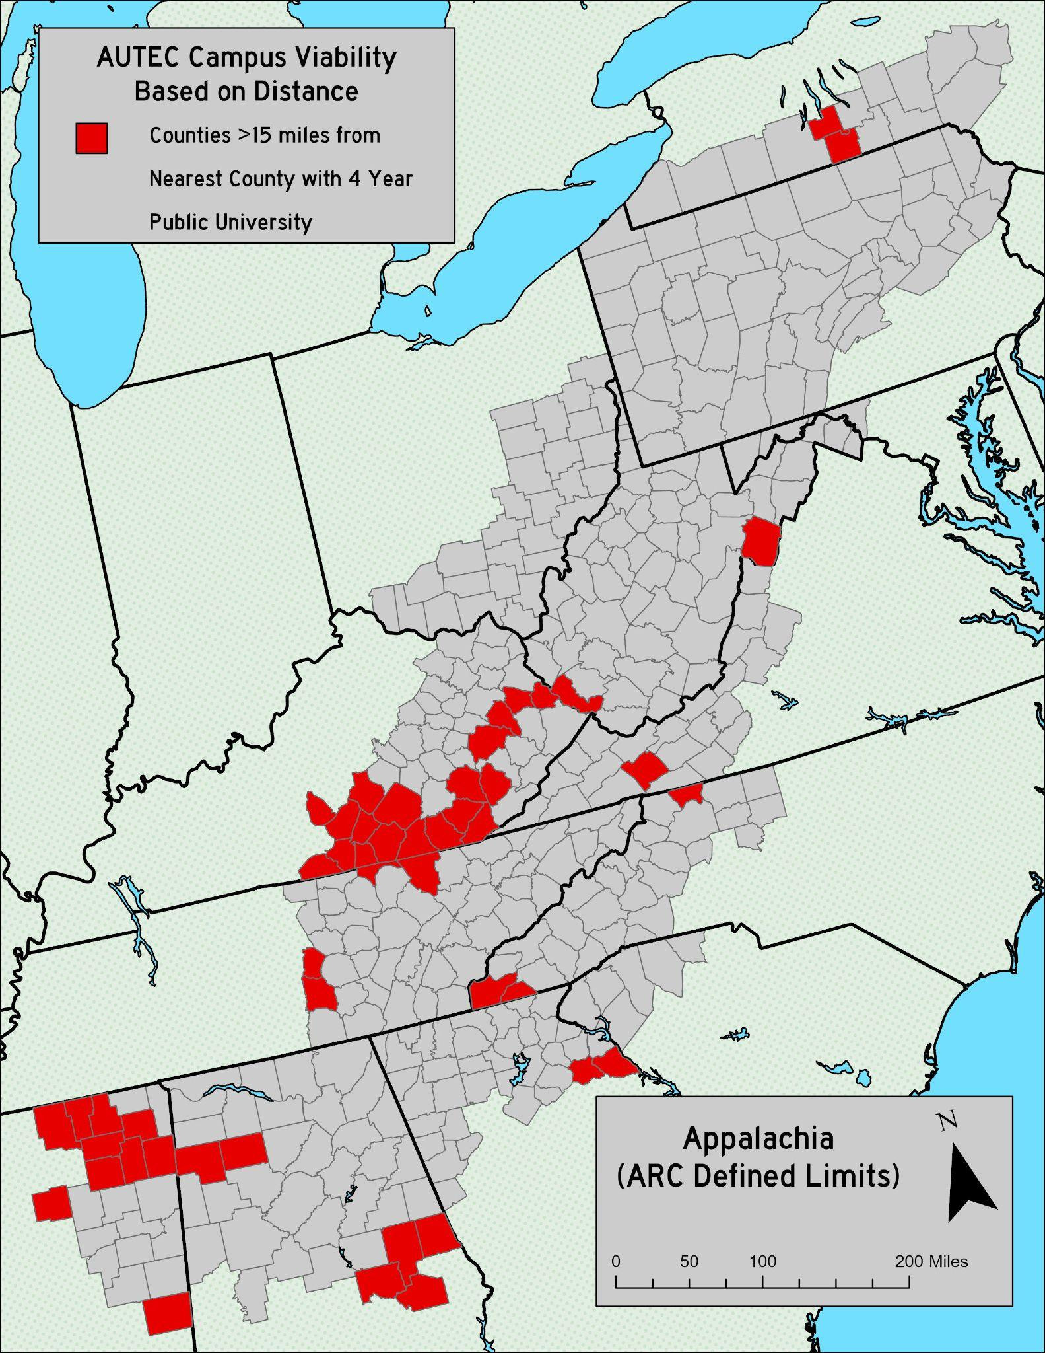
The areas with most suitability for a satellite campus fall within southeastern Ohio, western North Carolina, and north Georgia. There are also pockets in north central Alabama and eastern Tennessee, as well as east central Pennsylvania. Interestingly, many of the suitable counties are located nearby 4-year public universities. This is largely due to the universities being in population centers that expand into other counties that don’t benefit from the university in terms of education rates. This close proximity would make it easier for universities to operate satellite campuses as they would not be located particularly far away. However, a drawback of this site suitability is that it misses more rural areas that would also benefit from receiving a satellite campus.

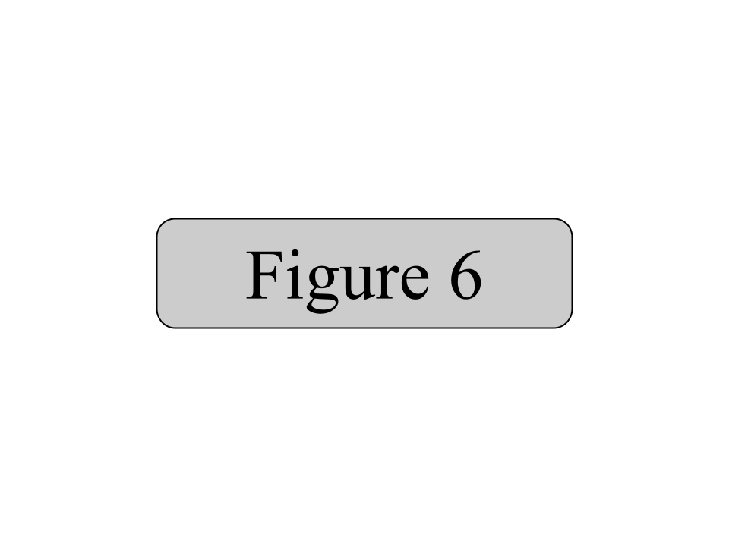
Therefore, another suitability metric was examined. Counties located at least 15 miles from the nearest county with a 4 year public university were picked out, shown in figure 6. These areas are higher education deserts. These areas are mostly in northern Mississippi, southern Kentucky, and some other small assorted areas around Appalachia.

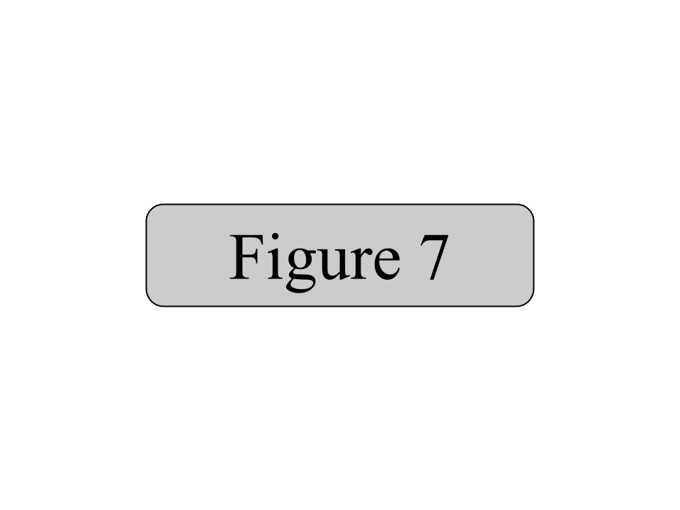
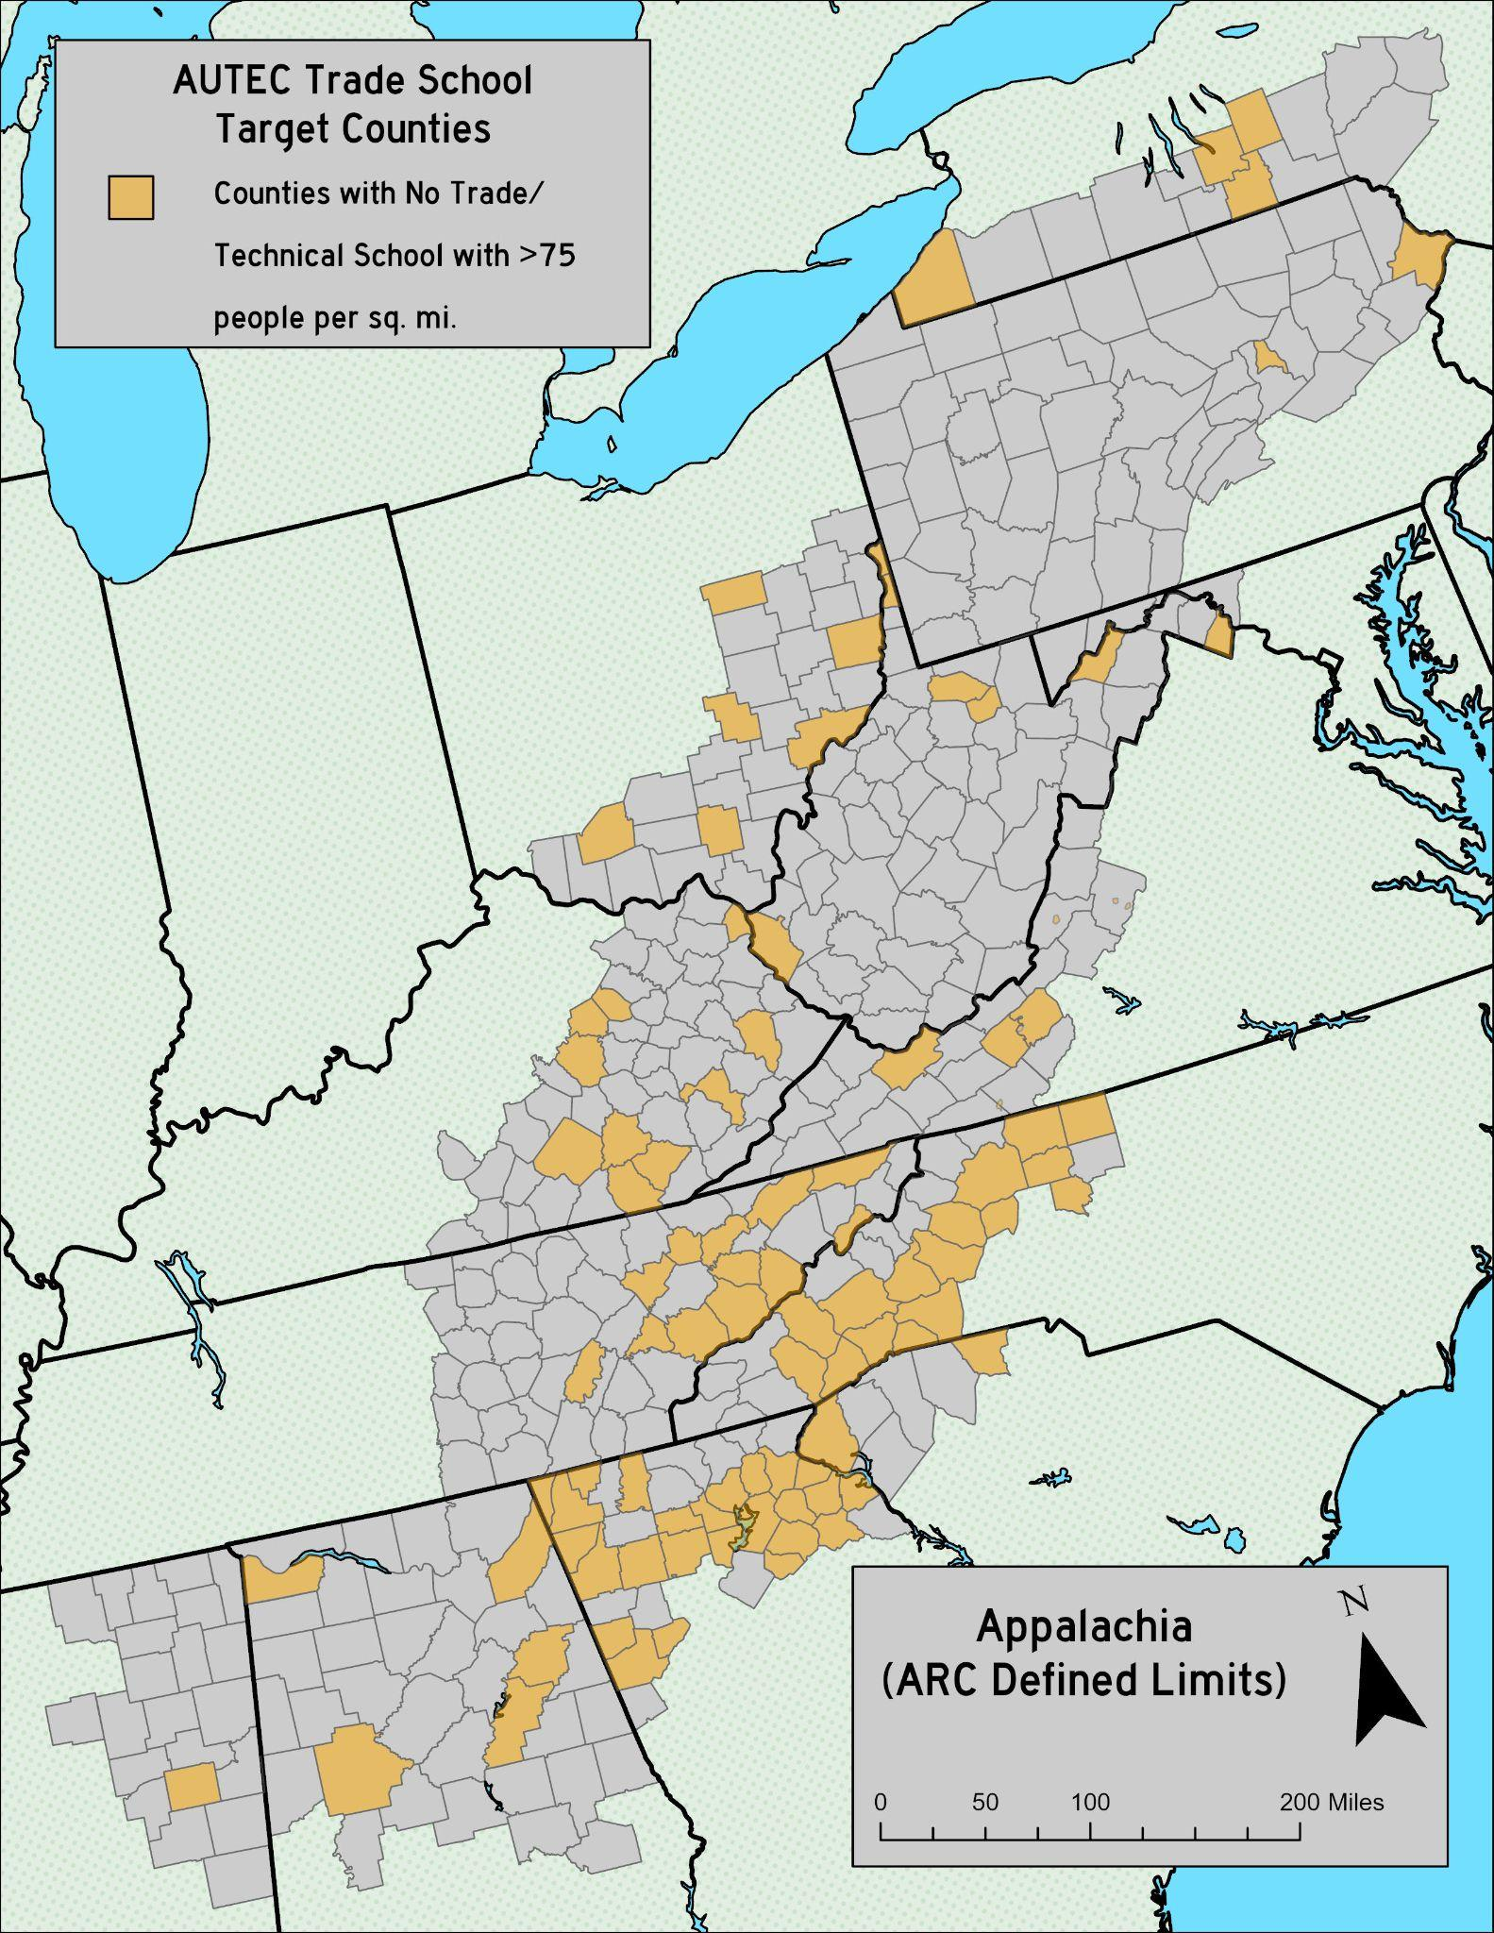
AUTEC will also focus on creating trade and technical institutions. The demand for these is based on the locations of existing trade and technical schools (from the USGS) and population density. Counties that qualify for a new trade school have a population density of at least 75 residents per square mile and no existing trade or technical school. This distribution is visualized in figure 7. Most of the demand is located in western North Carolina, north Georgia, and eastern Tennessee.

Through providing new satellite university campuses and trade schools, AUTEC will provide Appalachians with new career readiness and long term sustainable and accessible education institutions.
Regional Appalachian Public Transit System (RAPTS) Act

An act to create a unified public transit system in Appalachia, to promote clean and accessible travel throughout the Appalachian region, to facilitate easier access to all parts of said region, and stimulate travel to urban centers in said region.

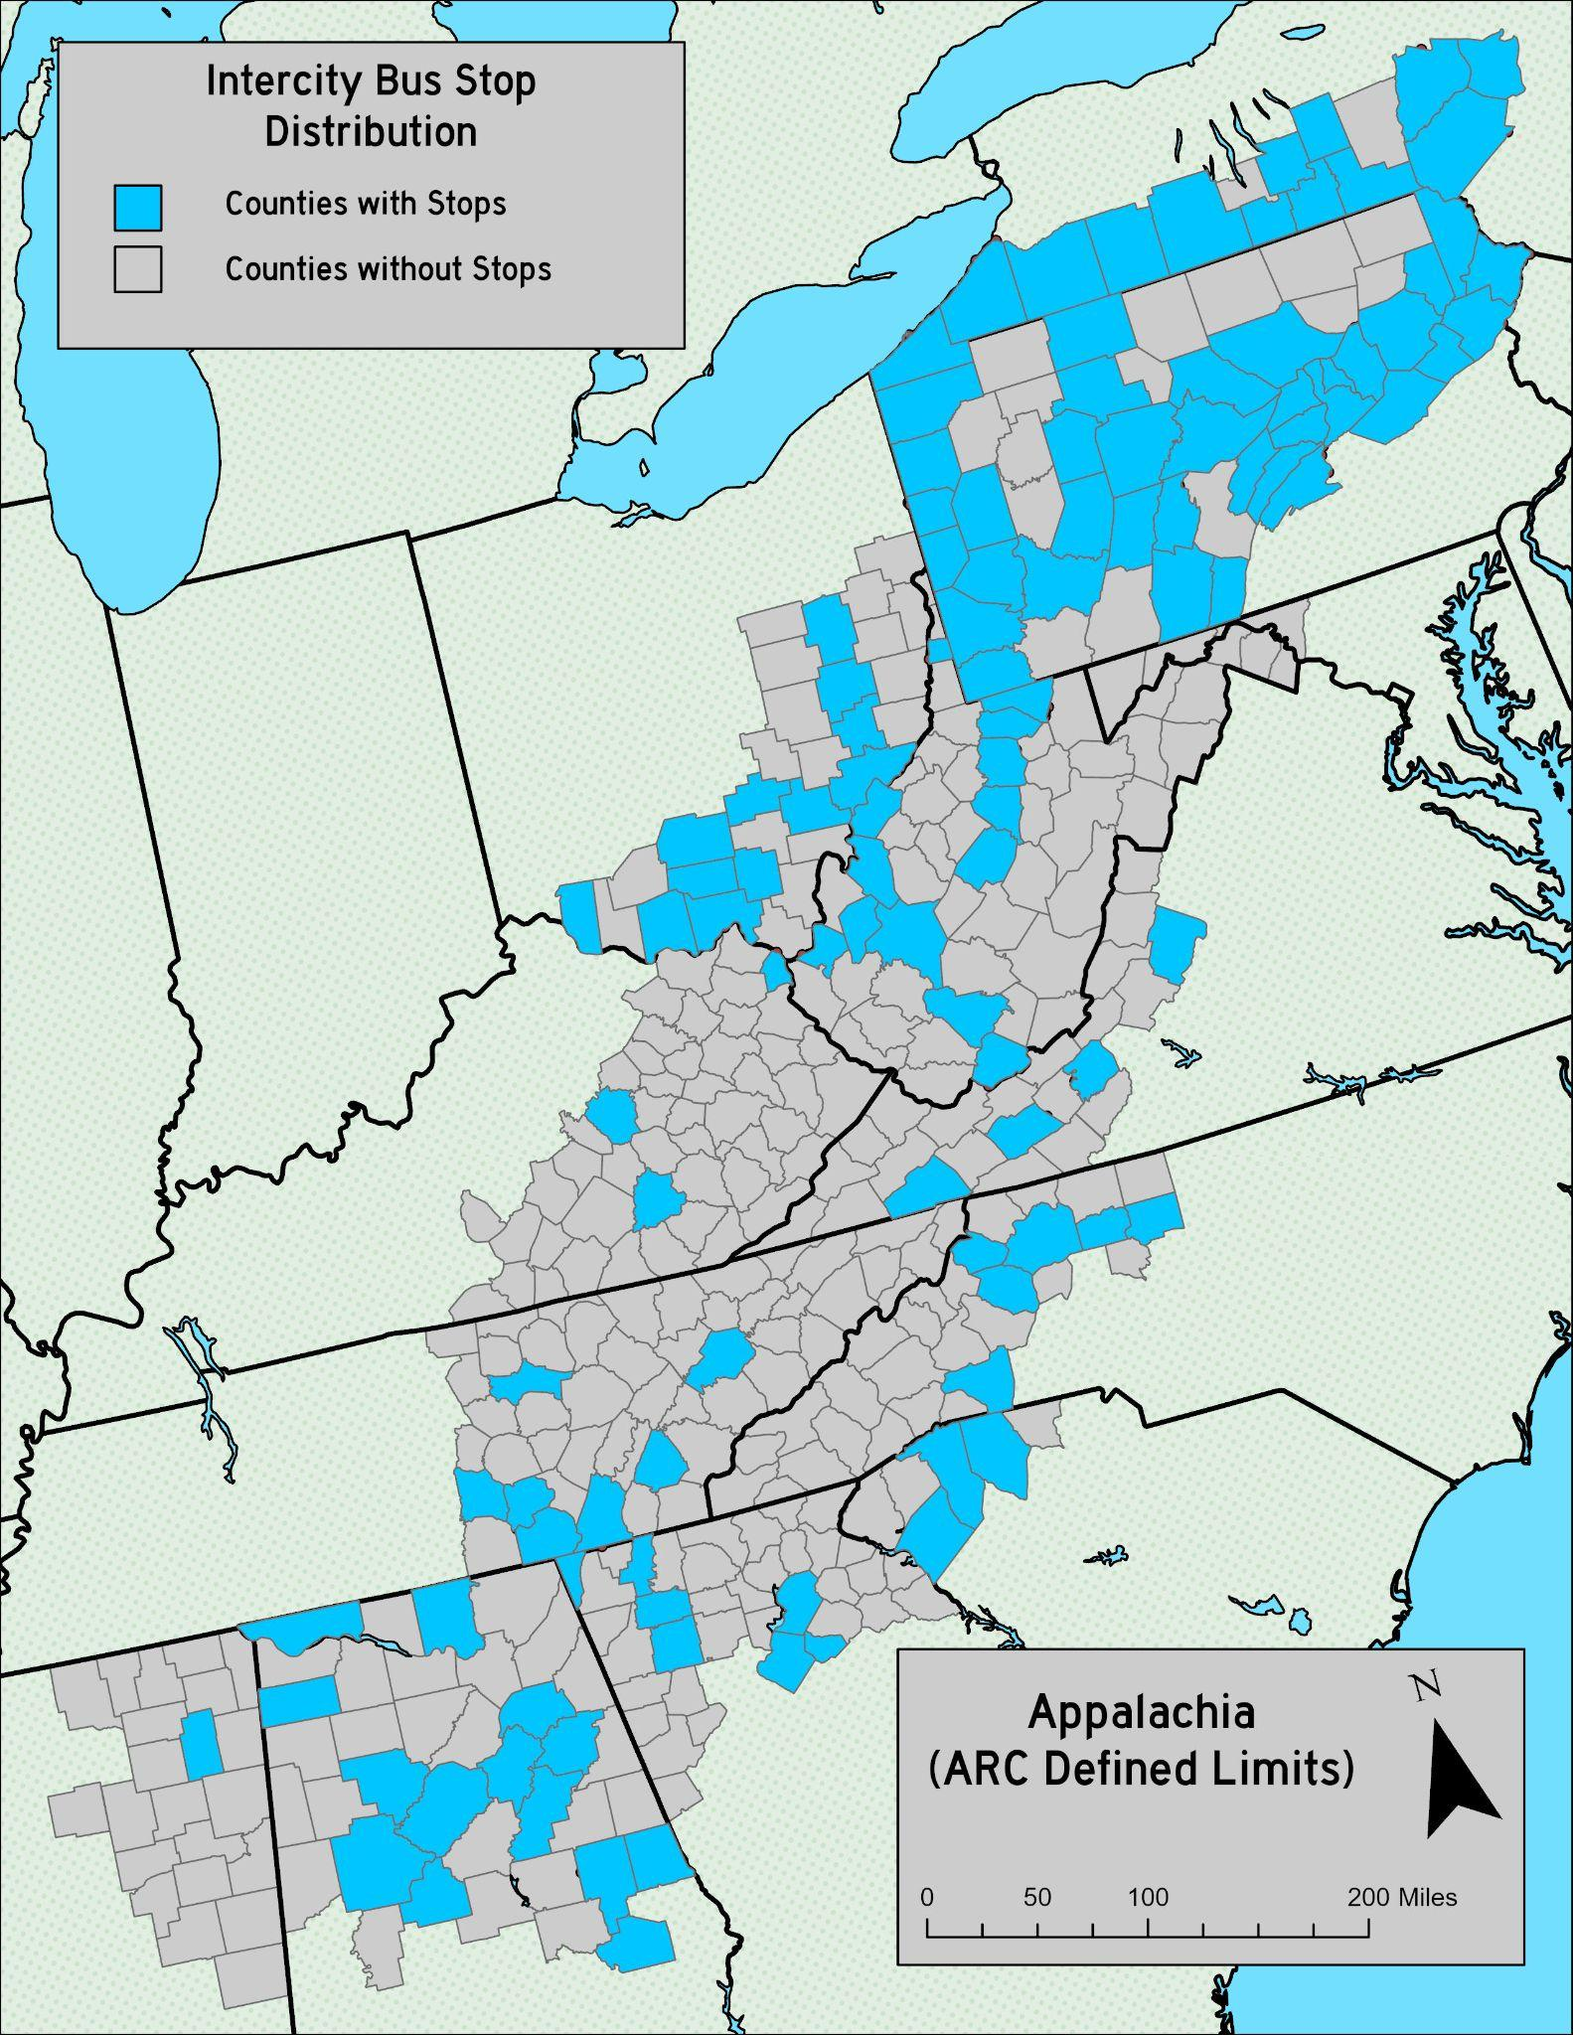
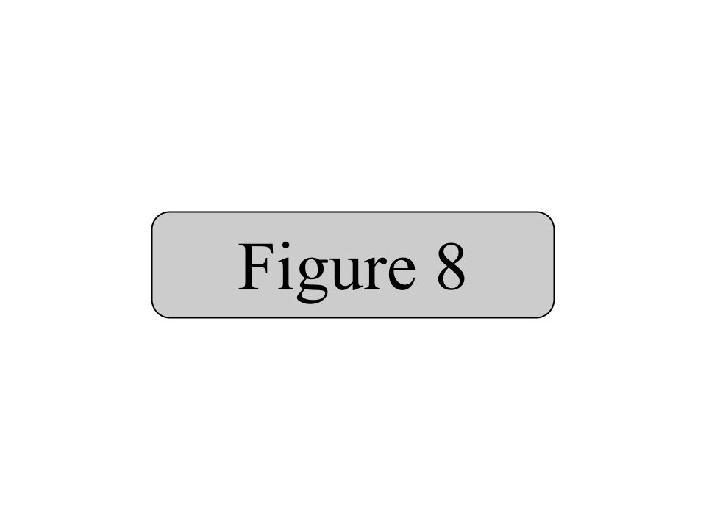
Appalachia is highly lacking in public transit service. Out of 423 counties, only 119 are served by intercity bus routes. Buses serve a variety of cities in the region but many others are lacking stops or are not near routes altogether. Buses are the primary mode of public transportation due to the high cost of building rail routes as a result of the mountainous terrain, while the existing road network can largely accommodate buses. Moreover, many states such as West Virginia are investing in new highway projects that buses can utilize for expedient travel.

The current distribution of intercity bus stops shows a clear north-south divide (see figure 8). Above the Mason-Dixon line, the vast majority of counties are served by intercity buses. However, heading south shows an increasing lack of bus service, with many states having fewer than ten stops in their Appalachian region. North Carolina has six, Virginia has four, Kentucky has three (despite having 54 counties in the region), and Mississippi has only one in Appalachia. This shows a clear lack of service to huge swaths of the Appalachian region.

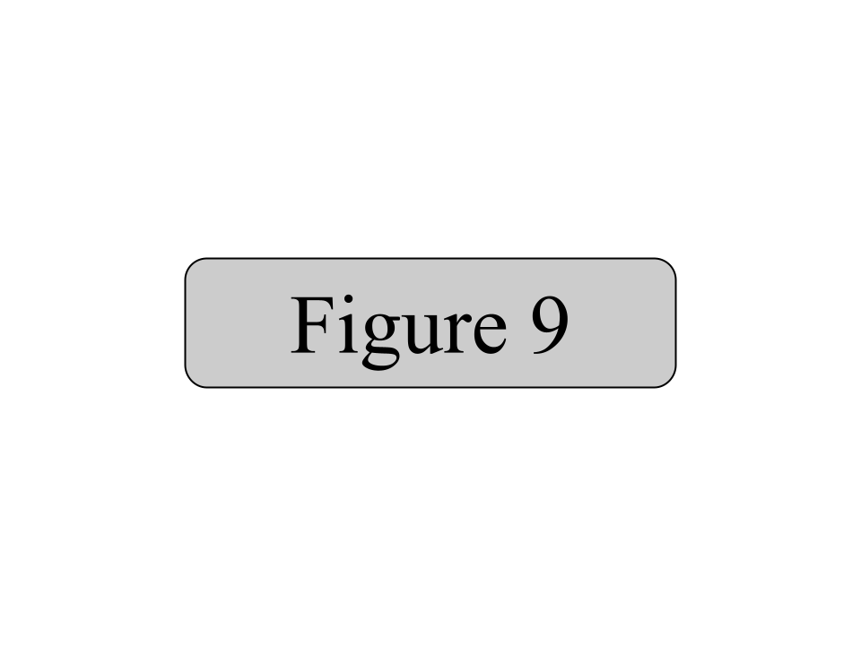
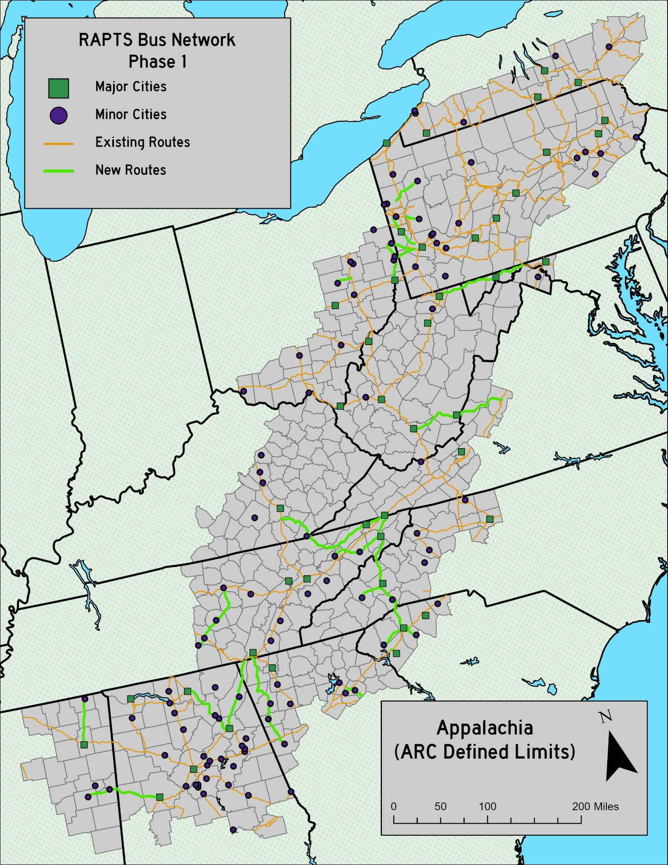
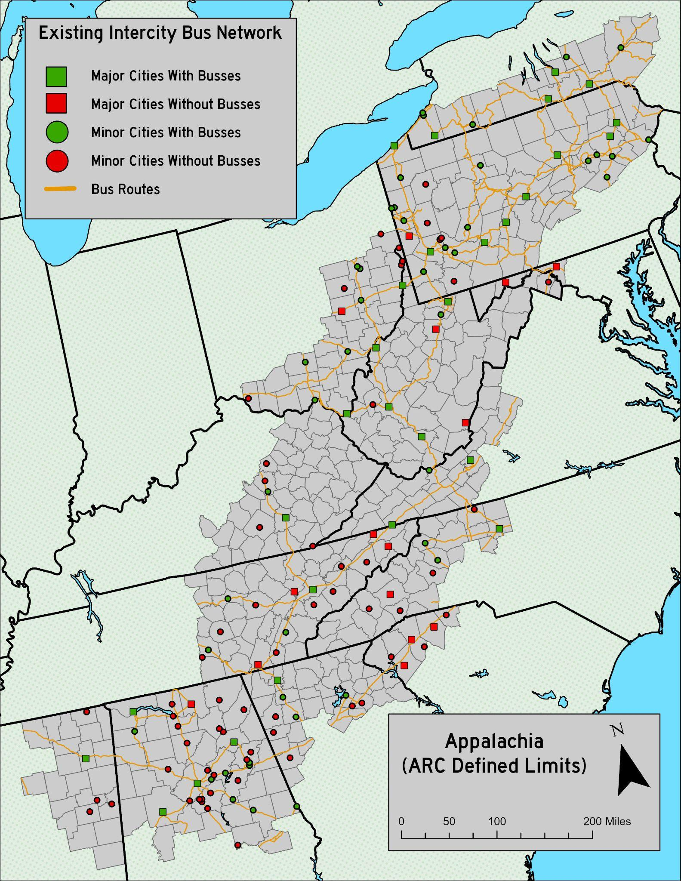
Looking at individual cities and bus routes, there is more of the same in terms of a Mason-Dixon divide (see figure 9). The vast majority of cities in Appalachian Pennsylvania and all cities in Appalachian New York are currently served by intercity buses. Bus routes are dense in this part of the region and allows these cities to be well connected by non-car transportation. However, further south is a different story. Bus routes are sparse, leaving over half the cities south of Pennsylvania unserved. Moreover, many cities on existing bus routes simply don’t have stops and are therefore excluded from service.

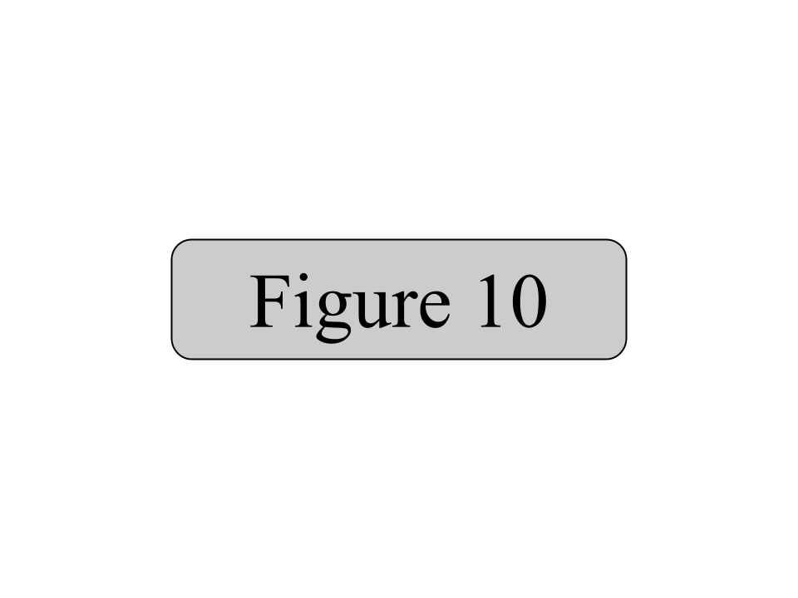
In order to provide seamless and high quality service, RAPTS will nationalize all intercity bus routes connecting to and within Appalachia. RAPTS will then expand into Phase 1. Phase 1 will involve creating new bus terminals in cities along existing intercity bus routes to cities that are not currently served. Phase 1 will also include adding new routes to serve all currently unserved major cities and most unserved minor cities in the region (see figure 10).

These new routes will connect new cities to the network, allowing for more car-free connections in Appalachia. It will increase the accessibility of the region and help feed local public transit systems. Future phases of RAPTS will increase the service density even further, serving smaller towns and operating commuter services. Public ownership will ensure that cities and towns will be served regardless of route profitability that could cause a for-profit private service provider to cease serving a location. Route service will be based on actual demand, not profitability as RAPTS is intended to act as a taxpayer funded public service, not a business.

Through constructing new bus routes and stops, as well as taking over legacy bus routes from private operators, RAPTS will be an affordable and reliable provider of public transportation throughout the Appalachian region.

Unified Board of Outdoor Appalachian Tourism (UBOAT) Act

An act to increase the numbers of tourists to Appalachia, provide new destinations for tourism in the Appalachian region, maintain and promote these destinations, and create tourism jobs for the people of Appalachia.

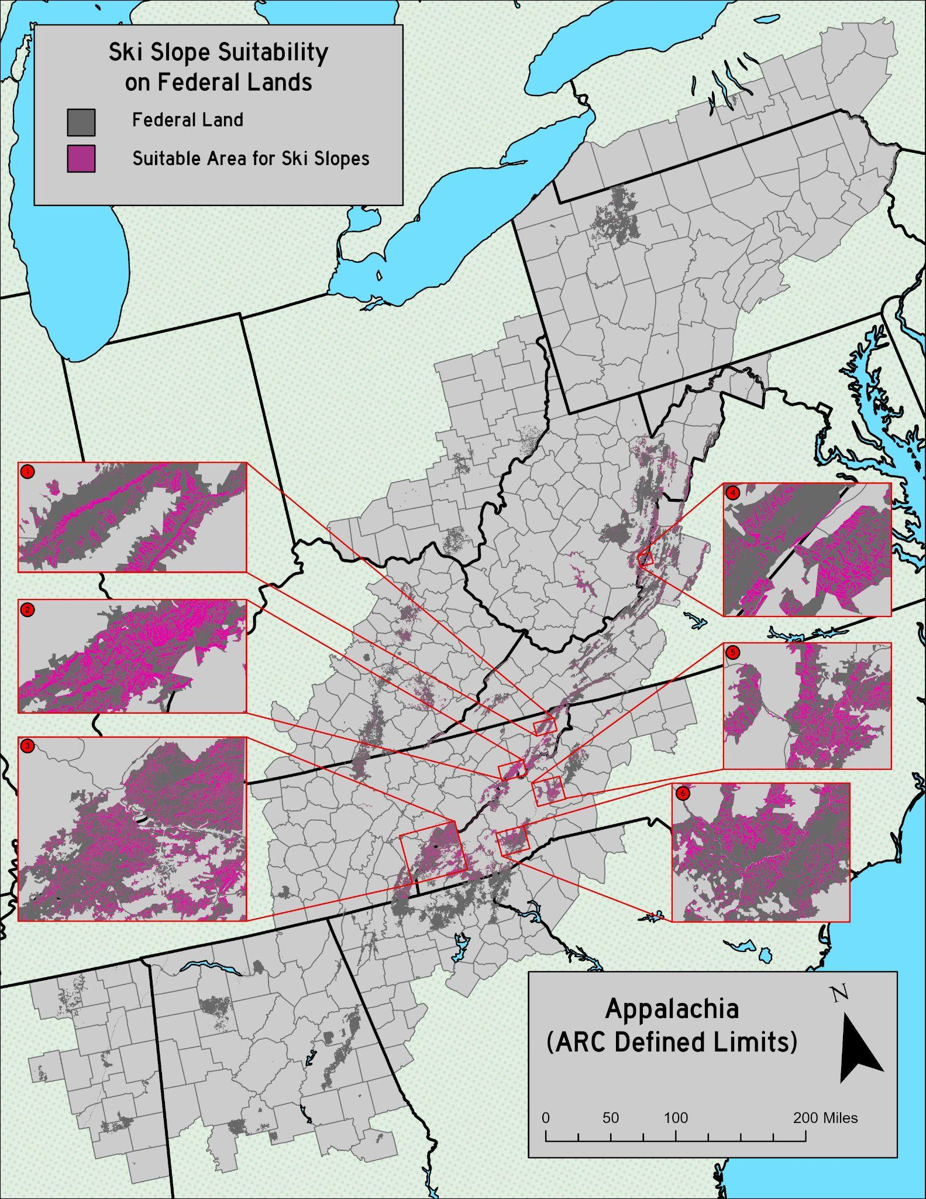
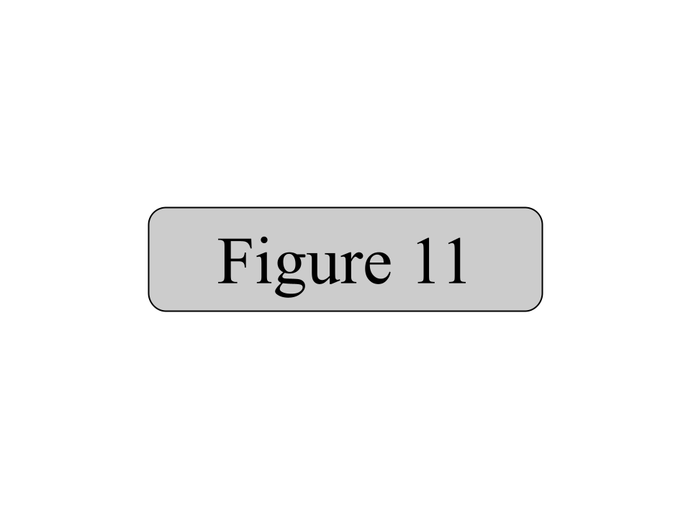
Appalachia is a region rich in natural beauty and ripe for tourism. However, tourist numbers are lagging behind what they should be. West Virginia received 77 million tourists in 2024 (West Virginia Department of Tourism), compared to over 95 million for Colorado (Colorado Office of Economic Development and International Trade). Both states offer similar outdoor amenities, with West Virginia located far closer to major population centers such as Northern Virginia and the Northeast Corridor. However, Colorado boasts 33 ski resorts while West Virginia offers only five. UBOAT intends to establish new ski resorts that can bring in tourists to West Virginia and the rest of Appalachia year-round.

Ski slopes are generally found on areas with a slope angle between 25^{O} for shallower slopes and 50^{O} for steeper, more advanced slopes. This angle of slope is shown in figure 11 overlaid on federally owned lands. Areas south of the southern Tennessee border were ignored due to high temperatures. Six areas of interest have been picked out. Areas 1 through 3 are located in eastern Tennessee, area 4 is located on the border of West Virginia and Virginia, and areas 5 and 6 are located in western North Carolina. All of these areas would be suitable for large, federally owned and operated ski resorts.

UBOAT intends to increase tourism year-round through the creation of these new resorts. These destinations will bring in an expected 200,000 to 500,000 tourists per year per resort, totalling potentially millions of additional tourists to the region and thousands of jobs depending on the number and size of resorts built. This number is based on the annual number of tourists for the Snowshoe resort (around 480,000), a large privately owned ski resort in West Virginia, as well as various other existing resorts in the region.

UBOAT will be a major economic driver for the Appalachian region, especially in eastern Tennessee and western North Carolina, some of the poorest parts of Appalachia. Tourism will support not only the resorts but local businesses as well. These resorts will also provide new residence options for wealthy out-of-state customers who can buy or lease a residence at the resort rather than buying up local housing stock and driving up prices for locals.

By constructing new ski resorts, UBOAT will create thousands of new jobs, bring in billions in tourist dollars, and stimulate the economies of some of the most economically depressed parts of the country.

Bibliography

Appalachian Regional Commission. Public Transportation in Appalachia – Inventory and Assessment. 2020. Accessed April 6, 2026.

Huber, Matt. Big Public Power from the River. 2023. Accessed April 3, 2026.

Huber, Matt. In Defence of the Tennessee Valley Authority. 2022. Accessed April 3, 2026.

Institute for Health Metrics and Evaluation. US Health Map. 2019. Accessed April 2, 2026.
Kitchens, Carl. The Role of Publicly Provided Electricity in Economic Development: The Experience of the Tennessee Valley Authority, 1929–1955. 2014. Accessed March 27, 2026.

Marti, Roscoe. The Tennessee Valley Authority: A Study of Federal Control. 1957. Accessed March 27, 2026.

Morgan, Arthur. Social Methods of the Tennessee Valley Authority. 1935. Accessed March 27, 2026.

Stafford, Fred. The Case for Public Nuclear Power. 2024. Accessed April 3, 2026.

Tennessee Valley Authority. Our Power System. 2026. Accessed March 26, 2026.

United Health Foundation. America's Health Rankings. 2024. Accessed April 2, 2026.

GIS Data References

HRSA - Medically Underserved Areas

OpenStreetMap - Healthcare Facilities

US Census Bureau - Education Rates, Population, Income

USGS - Education Institutions, Cities, Basemap Features, Transportation, DEM

